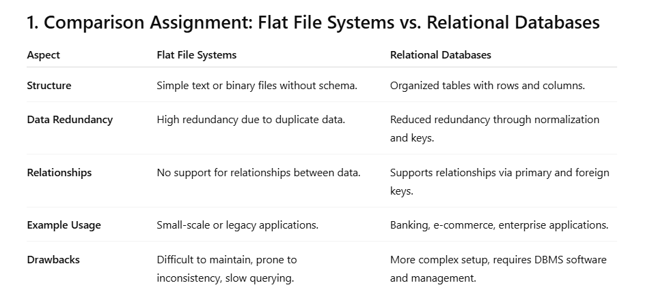

**2. DBMS Advantages – Mind Map**

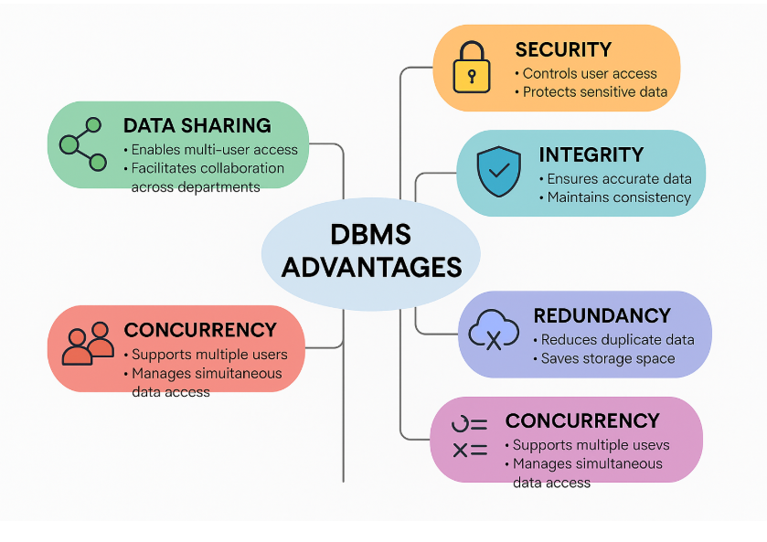

**3. Roles in a Database System**

* System Analyst:  
  Gathers and analyzes business requirements, bridges communication between business and technical teams.
* Database Designer:  
  Designs the logical and physical database schema, determines tables, columns, data types, and relationships.
* Database Developer:  
  Implements the database schema, writes SQL queries, stored procedures, and develops applications that interact with the database.
* Database Administrator (DBA):  
  Responsible for installing, configuring, securing, maintaining, and tuning the database system.
* Application Developer:  
  Develops applications that use the database backend to provide functionality to users.
* Business Intelligence (BI) Developer:  
  Creates reports, dashboards, and analytics to transform data into actionable insights.

**4. Types of Databases**

Relational vs. Non-Relational Databases

* Relational Databases (RDBMS):  
  Use structured tables with defined schema, support SQL queries. Examples: MySQL, PostgreSQL, Oracle.
* Non-Relational Databases (NoSQL):  
  Schema-flexible or schema-less, store unstructured or semi-structured data. Examples: MongoDB (document-based), Cassandra (wide-column).

Centralized vs. Distributed vs. Cloud Databases

* Centralized Databases:  
  Hosted on a single server, easier management but limited scalability.
* Distributed Databases:  
  Data spread across multiple servers/locations, improves fault tolerance and performance.
* Cloud Databases:  
  Hosted on cloud platforms, offering scalability, high availability, and reduced infrastructure management. Examples: Amazon RDS, Azure SQL Database, Google Cloud Spanner.

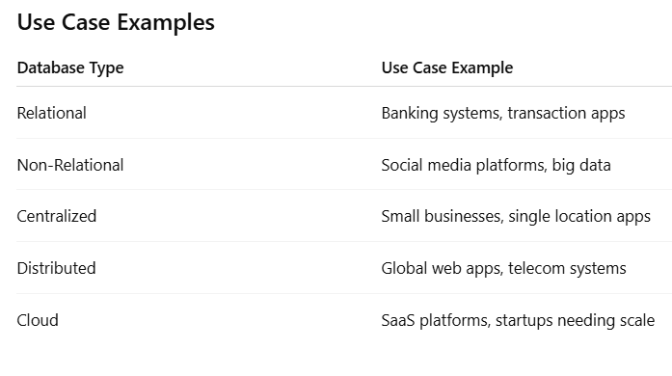

**5. Cloud Storage and Databases**

**What is Cloud Storage?**

Cloud storage is an internet-based service that stores data on remote servers, providing scalable, accessible storage without the need to manage physical hardware. It supports database functionality by hosting database files, backups, logs, and enabling database services.

**Advantages of Cloud-Based Databases**

* **Scalability:** Easily scale storage and compute resources.
* **Reduced Maintenance:** Cloud provider handles infrastructure management.
* **High Availability:** Built-in redundancy and failover.
* **Cost Efficiency:** Pay-as-you-use pricing models.
* **Accessibility:** Data accessible globally from anywhere with internet.

**Disadvantages or Challenges**

* **Internet Dependency:** Requires reliable internet connection.
* **Security Concerns:** Risks of data breaches and privacy.
* **Vendor Lock-in:** Difficulty migrating between cloud providers.
* **Latency Issues:** Possible delays depending on network and server location.